**Reverse vowels:**

It takes a string s as input and reverses the order of the vowels within that string, returning the modified string as output. The function iterates through the string, swapping vowels found at opposite ends of the string until the process reaches the middle.

1. **Problem solving:**

**Define Vowels:**

Start by defining the vowels, both in lowercase and uppercase, as an array. This allows easy checking if a character is a vowel.

**Split the String:**

Convert the input string s into an array of characters to make it easier to manipulate.

**Initialize Pointers:**

Initialize two pointers, left and right, pointing to the beginning and end of the string respectively.

**Iterate Through String:**

Use a while loop to iterate through the string.

**Find Vowels:**

Inside the loop, move the left pointer to the right until it points to a vowel and move the right pointer to the left until it points to a vowel.

**Swap Vowels:**

Swap the vowels found by the left and right pointers.

**Continue Until Pointers Meet:**

Continue steps 5 and 6 until the left pointer is equal to or greater than the right pointer.

**Join Characters:**

Convert the modified array back into a string.

**Return Result:**

Return the modified string with reversed vowels.

1. **Flow chart**

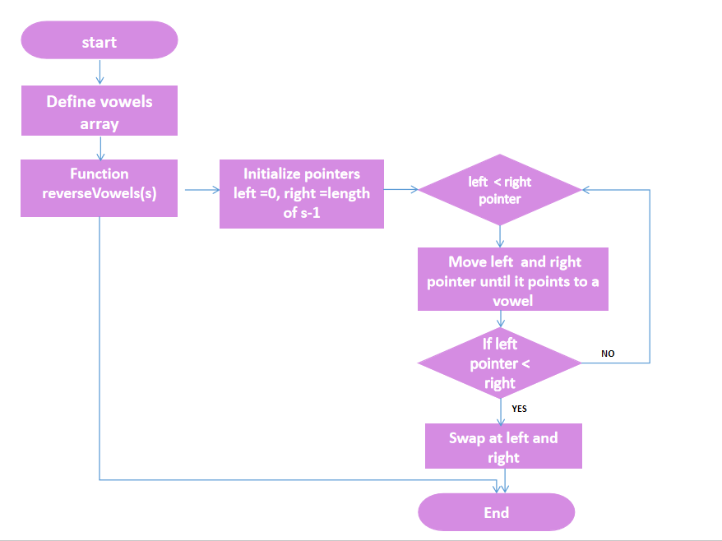

**End**

1. **Output**

